**1.** Write a SQL statement that displays all the information about all salespeople.

Sample table: salesman

Ans : create table salesman (

`salesman_id` int not null,

`name` varchar(35) null,

`city` varchar(20) null,

`commission` varchar(20) null,

primary key (`salesman_id`));

INSERT INTO `salesman` (`salesman_id`, `name`, `city`, `commission`)

VALUES ('5001', 'james Hoog', 'New York', '0.15');

INSERT INTO `salesman` (`salesman_id`, `name`, `city`, `commission`)

VALUES ('5002', 'Nail Knite', 'Paris', '0.13');

INSERT INTO `salesman` (`salesman_id`, `name`, `city`, `commission`)

VALUES ('5005', 'Pit Alex', 'London', '0.11');

INSERT INTO `salesman` (`salesman_id`, `name`, `city`, `commission`)

VALUES ('5006', 'Mc Lyon', 'Paris', '0.14');

INSERT INTO `salesman` (`salesman_id`, `name`, `city`, `commission`)

VALUES ('5007', 'Paul Adam', 'Rome', '0.13');

INSERT INTO `salesman` (`salesman_id`, `name`, `city`, `commission`)

VALUES ('5003', 'Lauson Hen', 'San Jones', '0.12');

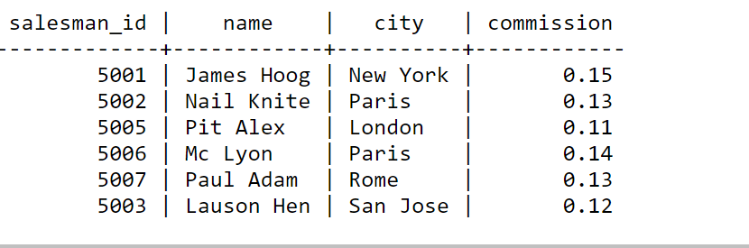

2. Write a SQL statement to display specific columns such as names and commissions for all salespeople.

Ans: select * from salesman;

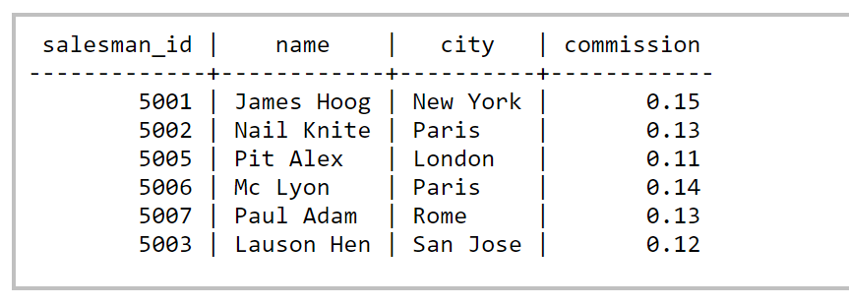

3. Write a query to display the columns in a specific order, such as order date, salesman ID, order number, and purchase amount for all orders.    
Sample table: orders

Ans:

create table oders (

`ord_no` int not null,

`purch_amt` varchar(35) null,

`ord_date` varchar(20) null,

`customer_id` int not null,

`salesman_id` int not null,

primary key (`ord_no`));

INSERT INTO `oders` (`ord_no`, `purch_amt`, `ord_date`, `customer_id`, `salesman_id`)

VALUES (‘7001’, ‘150.5’, ‘2012-10-05’, ‘3005’, ‘5002’ );

INSERT INTO `oders` (`ord_no`, `purch_amt`, `ord_date`, `customer_id`, `salesman_id`)

VALUES (‘7009’, ‘270.65’, ‘2012-09-10’, ‘3001’, ‘5005’ );

INSERT INTO `oders` (`ord_no`, `purch_amt`, `ord_date`, `customer_id`, `salesman_id`)

VALUES (‘7002’, ‘65.26’, ‘2012-10-05’, ‘3002’, ‘5001’ );

INSERT INTO `oders` (`ord_no`, `purch_amt`, `ord_date`, `customer_id`, `salesman_id`)

VALUES (‘7004’, ‘110.5’, ‘2012-08-17’, ‘3009’, ‘5003’ );

INSERT INTO `oders` (`ord_no`, `purch_amt`, `ord_date`, `customer_id`, `salesman_id`)

VALUES ('7007', '948.5', '2012-09-10', '3005' , ‘5002’);

INSERT INTO `oders` (`ord_no`, `purch_amt`, `ord_date`, `customer_id`, `salesman_id`)

VALUES ('7005', '2400.6', '2012-07-27', '3007' , ‘5001’);

INSERT INTO `oders` (`ord_no`, `purch_amt`, `ord_date`, `customer_id`, `salesman_id`)

VALUES ('7008', '5760', '2012-09-10', ‘3002’ , '5001');

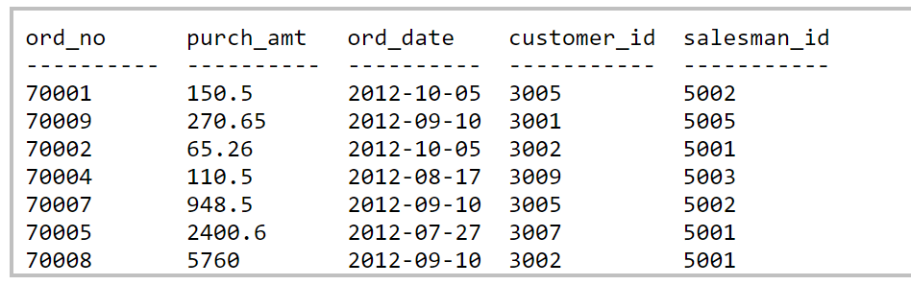

4. From the following table, write a SQL query to locate salespeople who live in the city of 'Paris'. Return salesperson's name, city.

Ans: SELECT * FROM salesman WHERE city = 'Paris';

Sample table: salesman

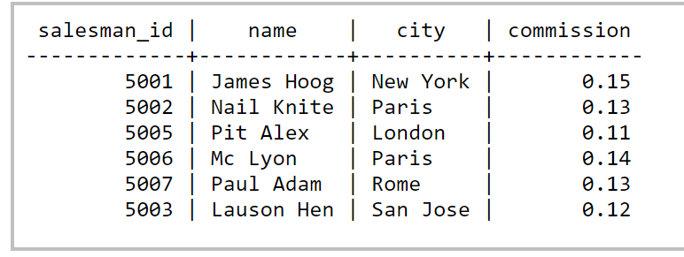

5. From the following table, write a SQL query to find customers whose grade is 200. Return customer_id, cust_name, city, grade, salesman_id.

Sample table: customer

Ans: SELECT * FROM customer WHERE grade = 200;

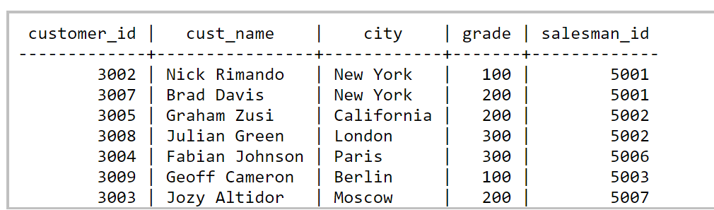

6. From the following table, write a SQL query to find those employees whose salaries are less than 6000. Return full name (first and last name), and salary.

Sample table: employees

Ans: SELECT * FROM employees WHERE salary < 6000;

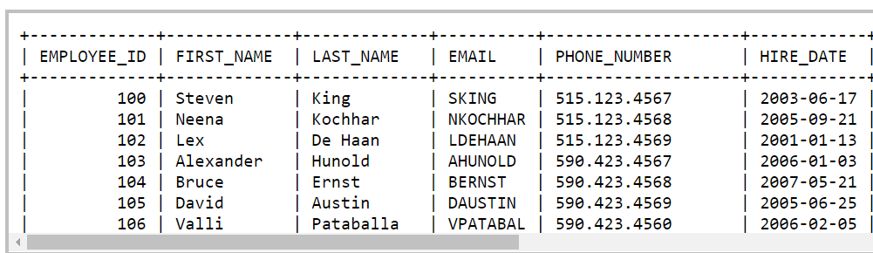

7. From the following table, write a SQL query to find those employees whose salary is higher than 8000. Return first name, last name and department number and salary.

Sample table: employees

Ans: SELECT * FROM employees WHERE salary > 8000;

8. From the following table, write a SQL query to find those employees whose last name is "McEwen". Return first name, last name and department ID.

Ans: SELECT * FROM employees WHERE LAST_NAME = ‘McEwen’;

9. From the following table, write a SQL query to identify employees who do not have a department number. Return employee_id, first_name, last_name, email, phone_number, hire_date, job_id, salary,commission_pct, manager_id and department_id.

Ans: SELECT * FROM employees WHERE department_number = null;

10. From the following table, write a SQL query to find the details of 'Marketing' department. Return all fields.

Sample table: departments

Ans: SELECT * FROM departments WHERE department_name = 'Marketing';

